Liability Waiver and Release  I know that running is potentially hazardous activity. I should not enter and run less I am medically able. I also assume any other risks associated with running in this event including, but not limited to, falls, contact with other participants, and effects of weather and conditions of the road. I understand I am solely responsible for my own safety while traveling to and from or participating in this event.  Knowing these facts and inconsideration of your acceptance of my entry, I hereby for myself, my heirs, executors, administrators, or anyone else who might sue on my behalf covenant not to sue, and waive, release, and discharge the sponsors or contributors to this event, any race officials, volunteers, their representatives successors or assignees from any and all claims of liability for death, personal injury, or property damage of any kind or nature whatsoever arising out of, or in the course of my participation.  The release form and waiver extends to all claims of every kind or nature whatsoever, foreseen and unforeseen, known and unknown. The undersigned further grants full permission to use any photographs or other record of the event for any purpose. Minors will be accepted with a parent’s signature.  Signature_________________________________  Date________________ |  |  |  |  |  | The Slippery Rock Rotary  Firecracker 5k run/2M walk  - July 4, 2019  Slippery Rock Community Park    All proceeds raised from the event will be donated to the rotary charities including the summer lunch program and the Slippery Rock Volunteer Fire and Rescue Department

FIRECRACKER 5k Run/Walk  July 4, 2019  Start Time  The race will begin at 8:00 am. Walkers will start 10 minutes after the runners.  For those who did not pre-register, registration begins at 7:15 am at the Veteran Pavilion.  Pre-Registration  To pre-register, and guarantee a t-shirt, return the attached entry form by June 21, 2019. Additional forms can be picked up at or downloaded from the Slippery Rock Rotary website Slipperyrockrotary.org.  Awards  $25 gift certificates will be given to the top male and female finisher in each age group.  $20 gift card will be given to the top runner or walker in the 12 and under age group.  Age Groups  Male and Female  45 & up, 44-30, 29-13  Youth: 12 and under |  |  | COURSE MAP  The race will start at the beginning of the walking trail by the Community Park Office and will loop through the park, pass by the Slippery Rock Elementary School and loop back into the park before ending at the Rotary Pavilion.  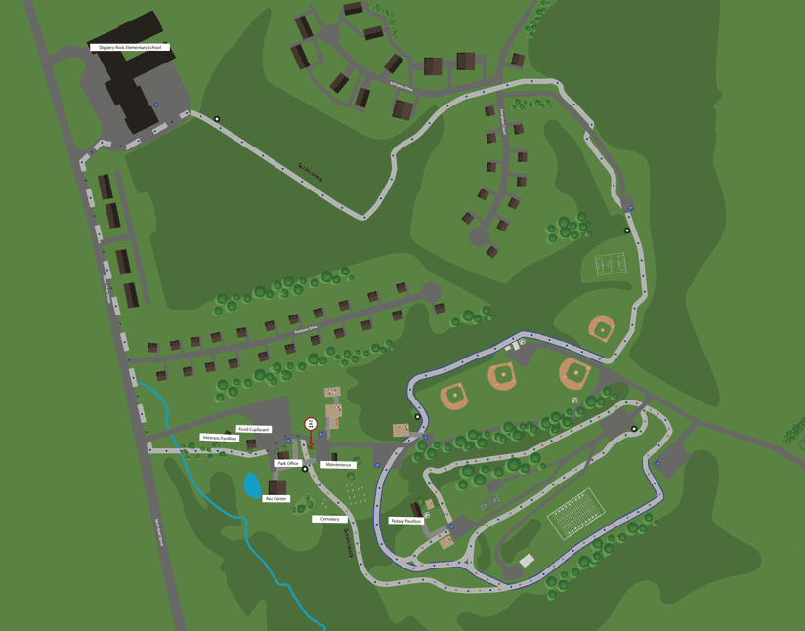  THANK YOU  Thank you to all of the donors and sponsors of the event.  A special thank you to the Slippery Rock Area Parks & Recreation for helping with the planning of this event and for allowing us to use the community park. |  |  | REGISTRATION ENTRY FORM  Only one entry per form.  In order to guarantee a t-shirt, all pre-registration forms must be submitted by Friday, June 21, 2019.  Name: _______________________________  Address:______________________________  City:_________________________________  State:____________ Zip:______________  Phone Number:________________________  Age:____________ Sex:______________  Email:_______________________________  Please circle T-shirt size:  Youth: S M L XL  Adult: S M L XL XXL  Make checks payable to: Slippery Rock Rotary  I will be _____ Running ______ Walking  Please check one:  Adult $25.00:_____ Discount $20.00:_____  Youth $20.00:______ Discount $15.00______  (12 and under)  All participants who bring a pair of lightly use or new shoes to donate to the Slippery Rock Rotary shoe drive will receive a $5.00 discount from their registration fee.  COMPLETE BACK TO FINISH REGISTRATION

